**Software Requirements Specification for "Quizify"**

## **1. Introduction can**

**1.1 Purpose**

The purpose of this document is to detail the requirements for the development of "Quizify," an online quiz game. It serves as a comprehensive guide for the project team and stakeholders.

## 

**1.2 Scope**

"Quizify" aims to create an interactive platform where users can engage in quizzes across various subjects, fostering competition, knowledge sharing, and a sense of community.

## 

## **2. Overall Description**

**2.1 Product Perspective**

"Quizify" will be a standalone web application utilizing a microservices architecture for scalability and a progressive web app (PWA) approach for a responsive user interface.

**2.2 Product Features**

User registration and authentication

Quiz creation and management

Randomized questions for quizzes

Scoring and leaderboards

Social interaction features (e.g., comments, likes)

Admin panel for content moderation

**2.3 User Classes and Characteristics**

Registered Users: Individuals who create quizzes and participate in others.

Admin Users: Responsible for content moderation and platform management.

## **3. Specific Requirements**

**3.1 External Interfaces**

User Interface: Intuitive and user-friendly design.

APIs: Utilize APIs for user authentication and potential future integrations.

**3.2 Functional Requirements**

a)-User friendly UI :

1)Pages for each feature in the website must be implemented

2)the ui should be different depending on what type of user has logged in

3)The navigation between pages must be easy

b)An SQL database is implemented for the website to access:

4-The queries to create the database is implemented

5-The database should be easily accessible for the front end

c)-User Registration and Authentication:

6-At least 2 types of Users should be able to create accounts.

7-The system must authenticate at least 2 types of users during login.

8-the system must differentiate between the different at least 2 types of users type of users

9-with each sign up the database is updated accordingly

c)Quiz Creation and Management:

10-Admins should be able to create quizzes

s)User Profile Management:

11-Users should be able to update their profiles.

12-User profiles should display quiz history and achievements.

e)Quiz Taking:

13-Users should be able to select and take available quizzes.

14-Users can retake quizzes.

15-The system should provide immediate feedback on answers.

Score Tracking:

16_The system must calculate and display scores upon quiz completion.

g)Admin Panel:

16_An admin panel to manage users, quizzes, and monitor site activity.

h)Search Functionality:

17-A search bar for easy navigation.

i)Responsive Design:

18-The website must be accessible and usable on various devices (desktops, tablets, mobile phones).

j)Data Backup and Recovery:

19-Regularly back up user data and quiz content.

20-A system for data recovery in case of system failure.

**3.3 Non-functional Requirements**

1-The website should load within a reasonable time frame.

2-Handle concurrent user sessions efficiently.

B)Scalability:

3-The system should be scalable to accommodate a growing user base.

4-Able to handle a significant increase in quiz submissions and user registrations

## **4. Constraints**

Development will be carried out by a team of four students.

Limited initial financial resources.

## **5. Assumptions and Dependencies**

Assumes a stable internet connection for users.

Dependent on the availability and reliability of external APIs for certain features.

## **6. Use Case Diagram**

Modified on the 12/19/2023

By:basmala amr

Added some use case diagrams

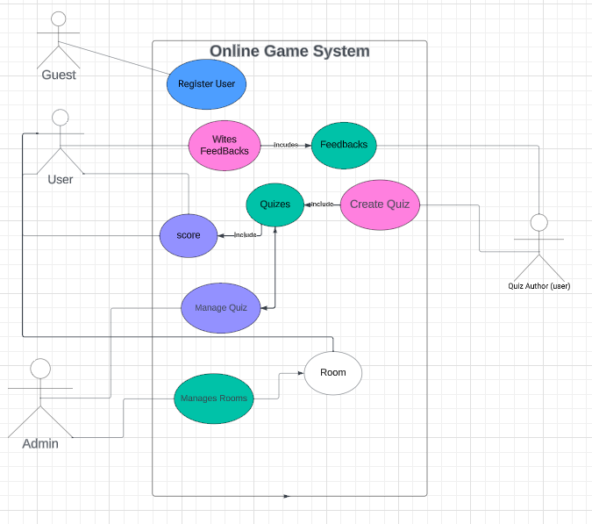

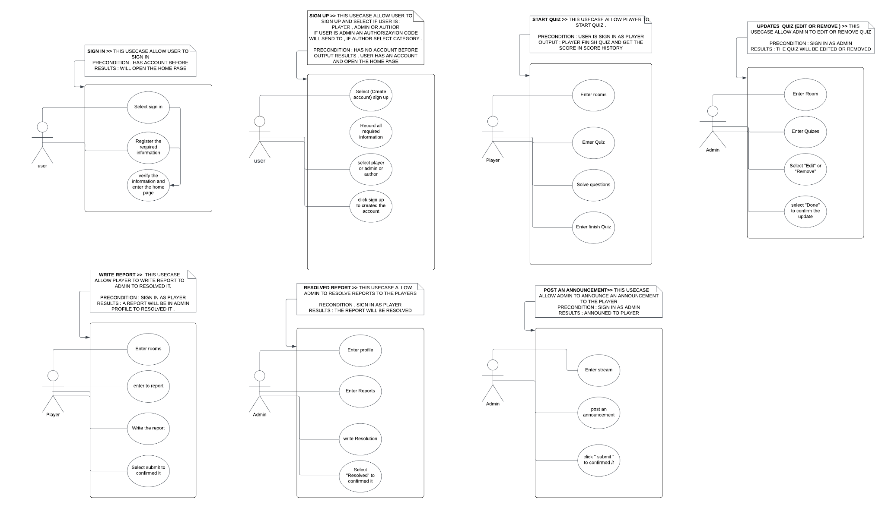

## **7. Context Diagram :**

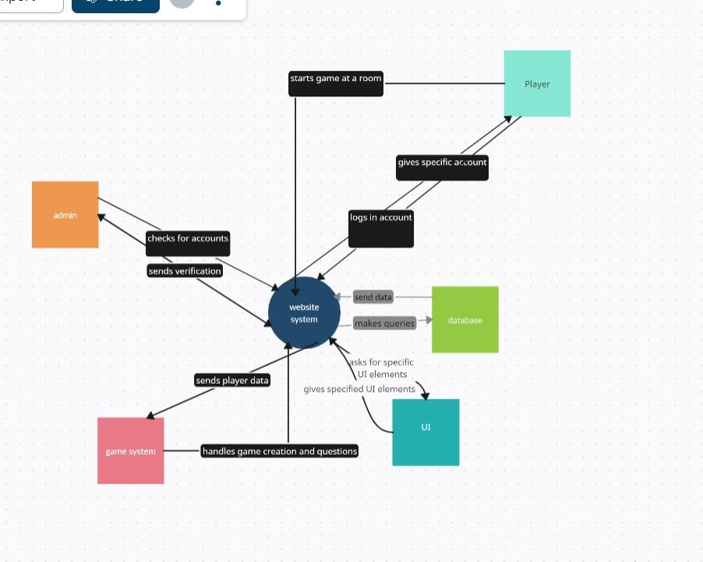

## **8. Concept Diagram**

## 

## 

## 

## **9. Class Diagram**

## 

**10. Crc cards:**Added on the 12/19/2023 by basmala amr and abdelrahman elkady created some class responsibility cards for the classes implemented up till now

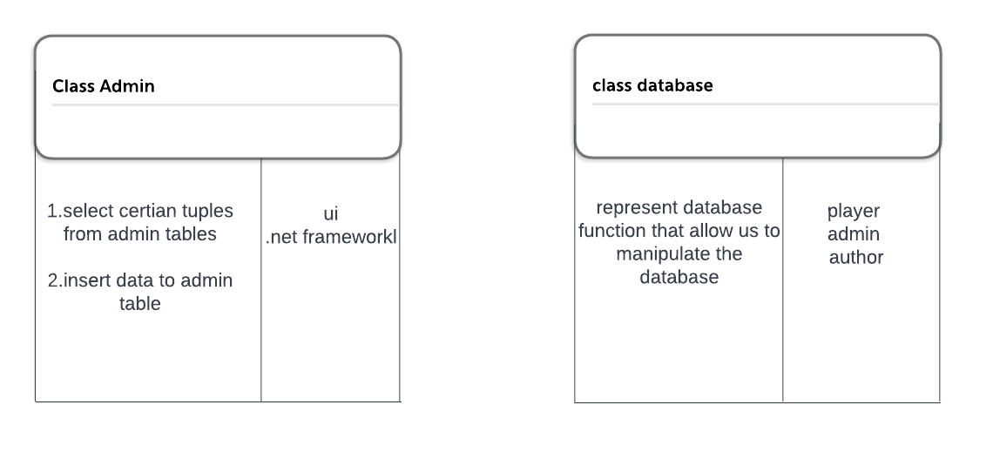

**11. Sequence diagram :**

Added on the 12/19/2023

By :basmala amr

Added sequence diagrams

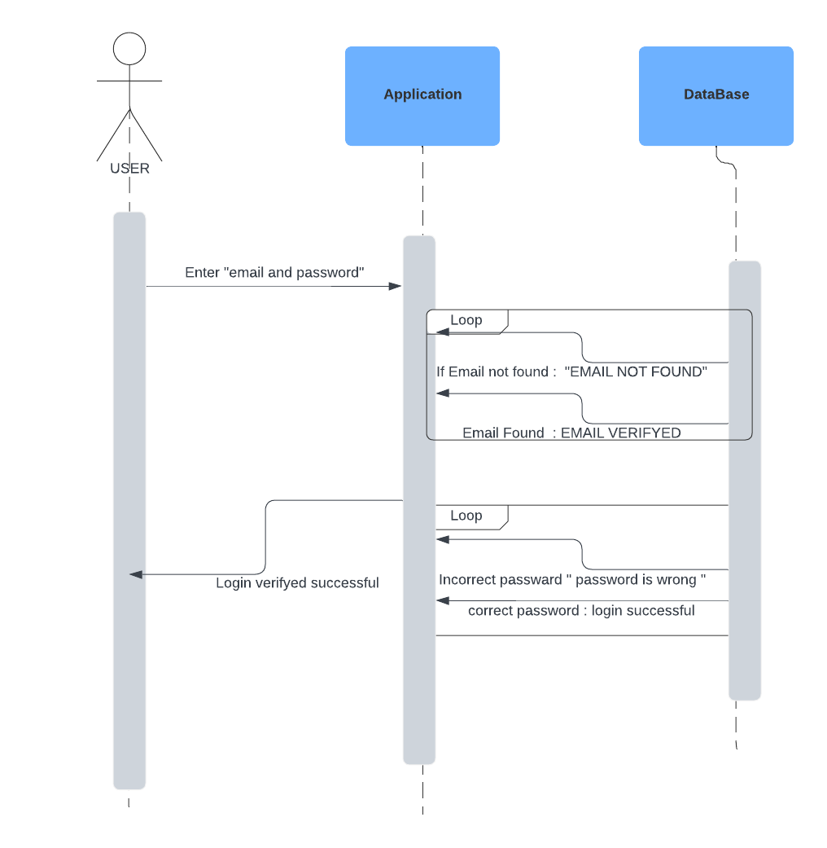

## **13.Sample UI**

Changed on the 18/12/2023

By :abdelrahman ameen and abdelrhaman elkady

We changed the look mainly and added some pages that were needed to further implement features

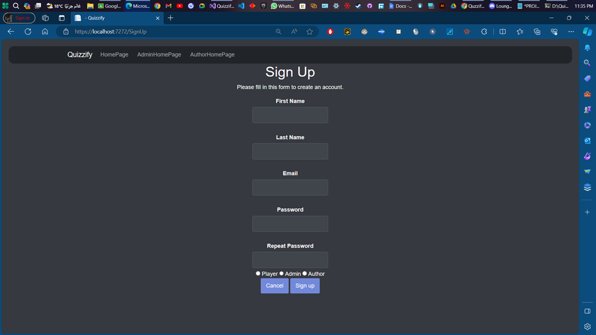

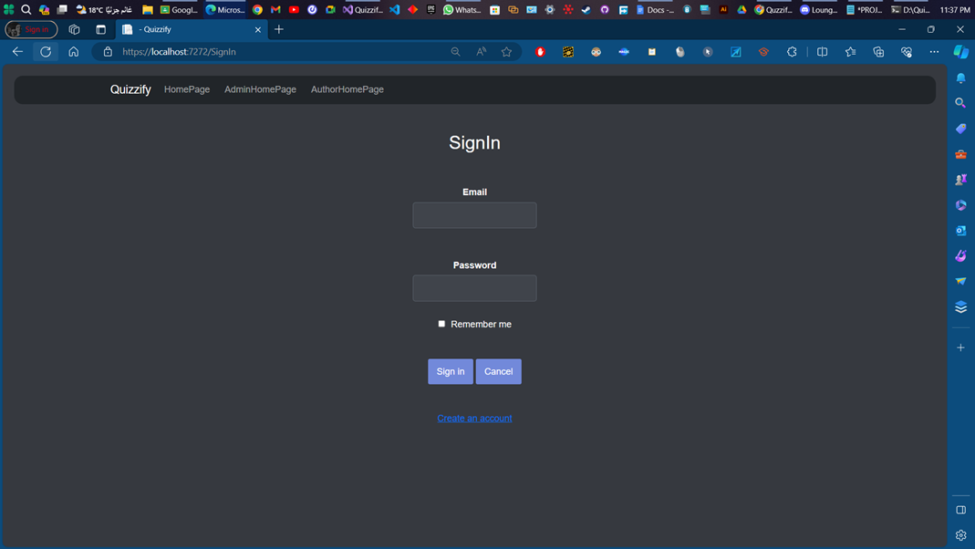

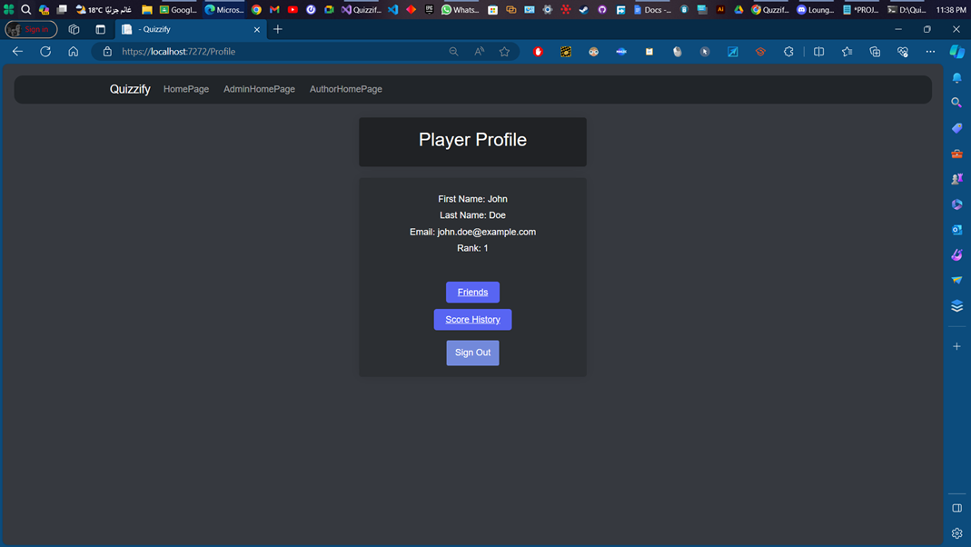

## **14. GitHub Repository**

Added by :abdelrahman elkady

Added the pbi and the code and furthermore

The source code for the "Quizify" project can be found on the GitHub repository at the following URL :

[itsamekadioo/Quizify (github.com)](https://github.com/itsamekadio/Quizify)